How to Disable Access to Payroll Salary information from Apps (Backend user ) but still Enable Access Only from Authorized and Audited Front End users (Payroll user).

Advantages of this Exercise
- Sysadmin will be able to control (Add/ Delete) Access to Salary information and Assign Access from the Seeded profile HR: User Type for a particular Responsibility
- Access to Payroll Table will be given only for this particular Responsibility and not to anyone Else even from Backend.
- Responsibility Access can be Audited at any point

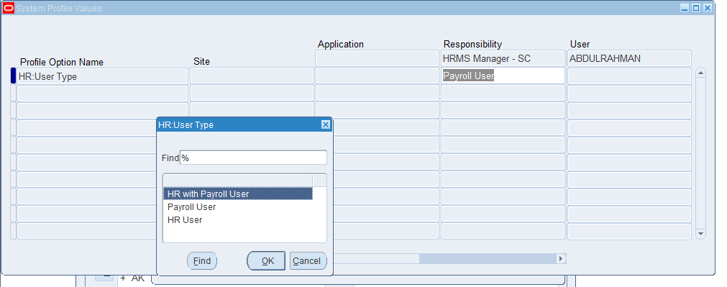

About This Exercise
Need to create an Oracle Virtual Private Database policy that limits access to all Salary Information in the APPS.PER_PAY_PROPOSALS table. In essence, the policy translates the following statement:
SELECT * FROM APPS.PER_PAY_PROPOSALS;
To the following statement:
SELECT * FROM APPS.PER_PAY_PROPOSALS
WHERE fnd_profile.value(‘HR_USER_TYPE’ ) =’Payroll User’

Step 1: Ensure That the APPS User Account Is Active
- Log on to SQL*Plus as user SYSTEM with the SYSDBA privilege.
- sqlplus apps
- Enter password: password

Step 2: Create a Policy Function
Create the following function, which will append the

fnd_profile.value(‘HR_USER_TYPE’ ) =’Payroll User’
Clause to any SELECT statement on the APPS.PER_PAY_PROPOSALS table. (You can copy and paste this text by positioning the cursor at the start of CREATE OR REPLACE in the first line.)
1  2  3  4  5  6  7  8  9  10  11  12 | CREATE OR REPLACE FUNCTION XXSC_RESTRICT_SALARY_ACCESS(  schema_var IN VARCHAR2,  table_var IN VARCHAR2  )  RETURN VARCHAR2  IS  return_val VARCHAR2 (400);  BEGIN  return_val := 'fnd_profile.value(''HR_USER_TYPE'' ) IN (''PAY'',''INT'') AND EXISTS ( SELECT 1 FROM V$SESSION where AUDSID = userenv(''SESSIONID'') and OSUSER=''applmgr'')';  RETURN return_val;  END XXSC_RESTRICT_SALARY_ACCESS;

In this Exercise:
- Lines 2–3: Create input parameters to specify to store the schema name, APPS, and table name, PER_PAY_PROPOSALS . First, define the parameter for the schema, and then define the parameter for the object, in this case, a table. Always create them in this order. The Virtual Private Database policy you create will need these parameters to specify the APPS.PER_PAY_PROPOSALS table.
- Line 5: Returns the string that will be used for the WHERE predicate clause. Remember that return value is always a VARCHAR2 data type.
- Lines 6–10: Encompass the creation of the predicate.
fnd_profile.value(‘HR_USER_TYPE’ ) =’Payroll User’

Step 3: Create the Oracle Virtual Private Database Policy

- Log on to SQL*Plus as user SYSTEM with the SYSDBA privilege.
- sqlplus sys as sysdba
- Enter password: password
Next, create the following policy by using the ADD_POLICY procedure in the DBMS_RLS package. (You can copy and paste this text by positioning the cursor at the start of BEGIN in the first line.)
1  2  3  4  5  6  7  8  9  10  11 | BEGIN  DBMS_RLS.ADD_POLICY (  object_schema => 'HR',  object_name => 'PER_PAY_PROPOSALS' ,  policy_name => 'XXSC_RESTRICT_SALARY_ACCESS',  function_schema => 'apps',  policy_function => 'XXSC_RESTRICT_SALARY_ACCESS',  statement_types => 'select, insert, update, delete'  );  END;  /

1  2  3  4  5  6  7  8  9  10  11 | BEGIN  DBMS_RLS.ADD_POLICY (  object_schema => 'HR',  object_name => 'PAY_COSTS' ,  policy_name => 'XXSC_RESTRICT_PAY_COSTS_ACCESS',  function_schema => 'APPS',  policy_function => 'XXSC_RESTRICT_SALARY_ACCESS',  statement_types => 'select, insert, update, delete'  );  end;  /

1  2  3  4  5  6  7  8  9  10  11 | BEGIN  DBMS_RLS.ADD_POLICY (  object_schema => 'HR',  object_name => 'PAY_BALANCE_FEEDS_F' ,  policy_name => 'XXSC_RESTRICT_BALANCES_ACCESS',  function_schema => 'APPS',  policy_function => 'XXSC_RESTRICT_SALARY_ACCESS',  statement_types => 'select, insert, update, delete'  );  END;  /

1  2  3  4  5  6  7  8  9  10  11 | BEGIN  DBMS_RLS.ADD_POLICY (  object_schema => 'HR',  OBJECT_NAME => 'PAY_RUN_RESULTS' ,  policy_name => 'XXSC_RESTRICT_RUN_RES_ACCESS',  function_schema => 'APPS',  policy_function => 'XXSC_RESTRICT_SALARY_ACCESS',  statement_types => 'select, insert, update, delete'  );  end;  /

1  2  3  4  5  6  7  8  9  10  11 | BEGIN  DBMS_RLS.ADD_POLICY (  object_schema => 'HR',  object_name => 'PAY_ELEMENT_ENTRY_VALUES_F' ,  policy_name => 'XXSC_RESTRICT_ENTRY_VALUES',  function_schema => 'APPS',  policy_function => 'XXSC_RESTRICT_SALARY_ACCESS',  statement_types => 'select, insert, update, delete'  );  END;  /

In this example:
- Line 3: Specifies the schema that you want to protect, that is, Apps.
- Line 4: Specifies the object within the schema to protect, that is, the PER_PAY_PROPOSALS table.
- Line 5: Names this policy Salary Information policy.
- Line 6: Specifies the schema in which the XXSC_RESTRICT_SALARY_ACCESS function was created. In this example, XXSC_RESTRICT_SALARY_ACCESS was created in the SYS schema. But typically, it should be created in the schema of a security administrator.
- Line 7: Specifies a function to enforce the policy. Here, you specify the XXSC_RESTRICT_SALARY_ACCESS function that you created in Step 2: Create a Policy Function.
- Line 8: Specifies the operations to which the policy applies. In this example, the policy applies to all SELECT, INSERT, UPDATE, and DELETE statements the user may perform.

Step 4: Test the Policy
After you create the Oracle Virtual Private Database policy, it goes into effect immediately. The next time a user, including the owner of the schema, performs a SELECT on APPS.PER_PAY_PROPOSALS, only the Salary Information Log on as user apps.
- CONNECT apps
- Enter password: password
- Enter the following SELECT statement:
- SELECT COUNT(*) FROM PER_PAY_PROPOSALS
1  2  3  4  5  6 | SELECT COUNT(1) FROM PAY_COSTS;  SELECT COUNT(1) FROM PAY_ELEMENT_ENTRY_VALUES_F;  SELECT COUNT(1) FROM PAY_BALANCES_V;  SELECT COUNT(1) FROM PAY_RUN_RESULTS;  SELECT COUNT(1) from PER_PAY_PROPOSALS;  SELECT COUNT(1) FROM PAY_BALANCE_FEEDS_F;

The following output should appear:
COUNT(*)
---------
0
The policy is in effect for user apps : As you cannot see any rows in the Salary Information table.
But users with administrative privileges (Responsibility with Profile HR:User Type) still have access to all the rows in the table.
- Log back on as application user Janine
- Enter password: password
- Query from the Front End you should be able to see information for all user from Janine Login

Step 5: Remove the Components for This Exercise
- As user SYS, remove the function and policy as follows:
- DROP FUNCTION XXSC_RESTRICT_SALARY_ACCESS;
- as SYS user run
1  2  3  4  5  6  7  8  9  10  11 12  13  14 | EXEC DBMS_RLS.DROP_POLICY('HR','PER_PAY_PROPOSALS','XXSC_RESTRICT_SALARY_ACCESS');  EXEC DBMS_RLS.DROP_POLICY('HR','PAY_COSTS' ,'XXSC_RESTRICT_PAY_COSTS_ACCESS');  EXEC DBMS_RLS.DROP_POLICY('HR', 'PAY_RUN_RESULT_VALUES' ,'XXSC_PP_ACCESS');  EXEC DBMS_RLS.DROP_POLICY('HR','PAY_PRE_PAYMENTS#' ,'XXSC_PP_ACCESS');  EXEC DBMS_RLS.DROP_POLICY('HR','PAY_LATEST_BALANCES#' ,'XXSC_LATEST_BALANCES');  EXEC DBMS_RLS.DROP_POLICY('HR', 'PAY_BALANCE_FEEDS_F' ,'XXSC_RESTRICT_BALANCES_ACCESS');  EXEC DBMS_RLS.DROP_POLICY('HR','PAY_RUN_RESULTS','XXSC_RESTRICT_RUN_RES_ACCESS');  EXEC DBMS_RLS.DROP_POLICY('HR','PAY_ELEMENT_ENTRY_VALUES_F','XXSC_RESTRICT_ENTRY_VALUES');  EXEC DBMS_RLS.DROP_POLICY('HR','PAY_ASSIGNMENT_ACTIONS' ,'XXSC_RESTRICT_ASS_ACCESS');  EXEC DBMS_RLS.DROP_POLICY('HR','PAY_ELEMENT_ENTRY_VALUES_F' ,'XXSC_RESTRICT_ENTRY_VALUES');  EXEC DBMS_RLS.DROP_POLICY('HR','PAY_EXTERNAL_ACCOUNTS' ,'XXSC_PP_ACCESS');

Step6: Audit Script to Check for Active Policies
- As user SYS or APPS
1 | SELECT * FROM ALL_POLICIES WHERE POLICY_NAME LIKE 'XXSC%';

